Microsoft Forms in Office 365 and Lingt.com
Are you looking for ways to have your students practice test taking skills? Do your students need help with skimming and scanning? Do your students need more listening and speaking practice? Here are a couple different ways to help while also including technology…or not, some of this can be done on paper.
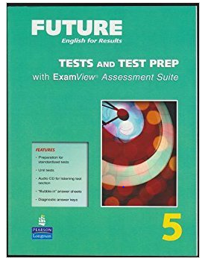
READING: Microsoft Forms in Office 365 (can be copied from the Tests and Test Prep Book and completed with paper and pencil if you choose)
Can be used with a Book Club
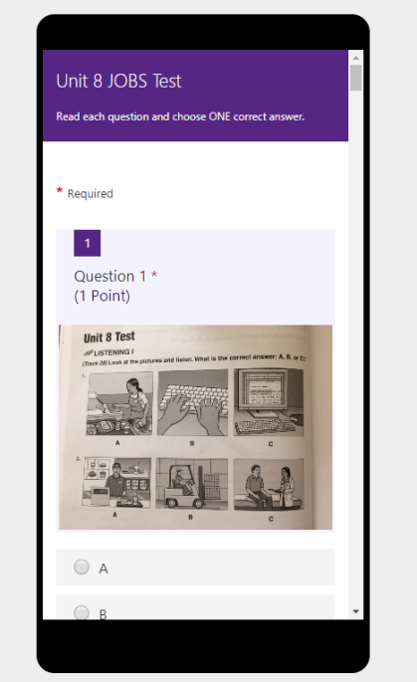
Can be used on the computer
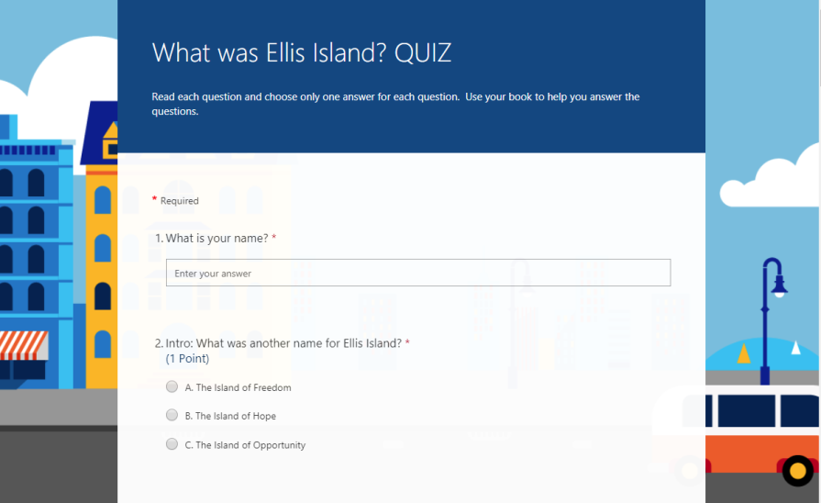

Can be used as you finish a unit in the book
Can be used on smart phones

*Example: Unit 2 Test on the Family Intermediate I https://forms.office.com/Pages/ResponsePage.aspx?id=Cx5ATVJlCE69OKjRXKDd2aSXHZOJU_9GvZ9FELo7tcRUNDY5U0Q2Q09EWDVLVU5VTVNTTUNNSDFTNi4u
*How to create a quiz in Microsoft Forms
https://www.youtube.com/watch?v=yVKEBdcocgw
How to create a survey in Microsoft Forms
https://www.youtube.com/watch?v=-OzDE6XE0T4

LISTENING/SPEAKING: Lingt.com
Lingt.com how to get an account, create a class,
create an assignment
https://www.youtube.com/watch?v=HV2TJ7AvjFE
https://www.lingt.com/

Example: Introduction Beginning II
https://www.lingt.com/ms.%20watkins/mc-esol-intermediate-i-sum2018/83448/intermediate-i-summer-2018-introduction-92/

