QR CODES

Begin:
download the app from the app store, google play, etc.
I-Nigma QR Code Reader

Question:

What can you do with QR codes?

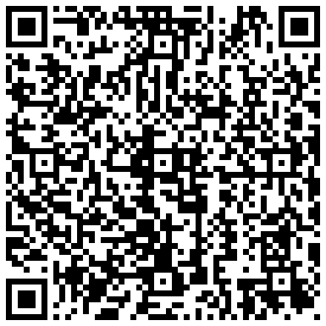

You can use many different QR code generators.
For example:
–Goo.gl
–QR Hacker,
–Kaywa,
–GoQR,
–QR Stuff,
–QR Droid Code Generator.

I like http://qrcode.kaywa.com

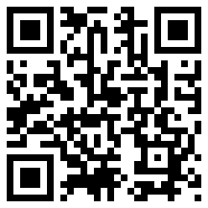 | Text –  - Use to check a grammar point.  - Use to check comprehension.  - 3. Use to share student content.
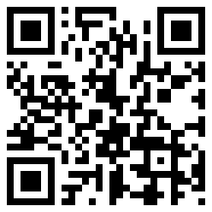 | URL –  - Share resources.
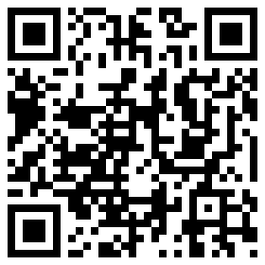 | URL –  - Share online tools.
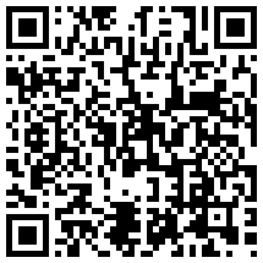 | URL-  - Share infographics.
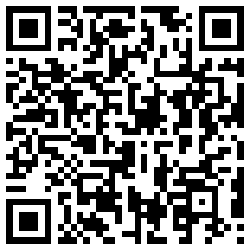 | URL –  - Share audio from a link
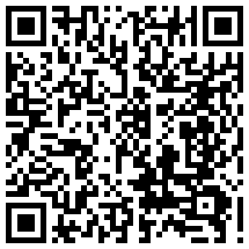 | Voice-  - Record instructions. (Use voice recorder and share to get a URL link)  - Share short student made recordings.

