TRIED AND TRUE CLASSROOM COMMUNITY
BUILDING ACTIVITIES QUICK SHARE

1. Greet Students at the door of the classroom making eye contact during the first 3-5 classes.

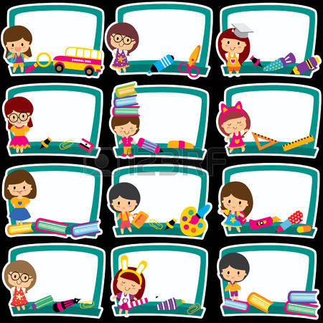
2. Write student's first name on a name tag and have them wear it the first 3 classes in order to familiarize you and each other with their peers.

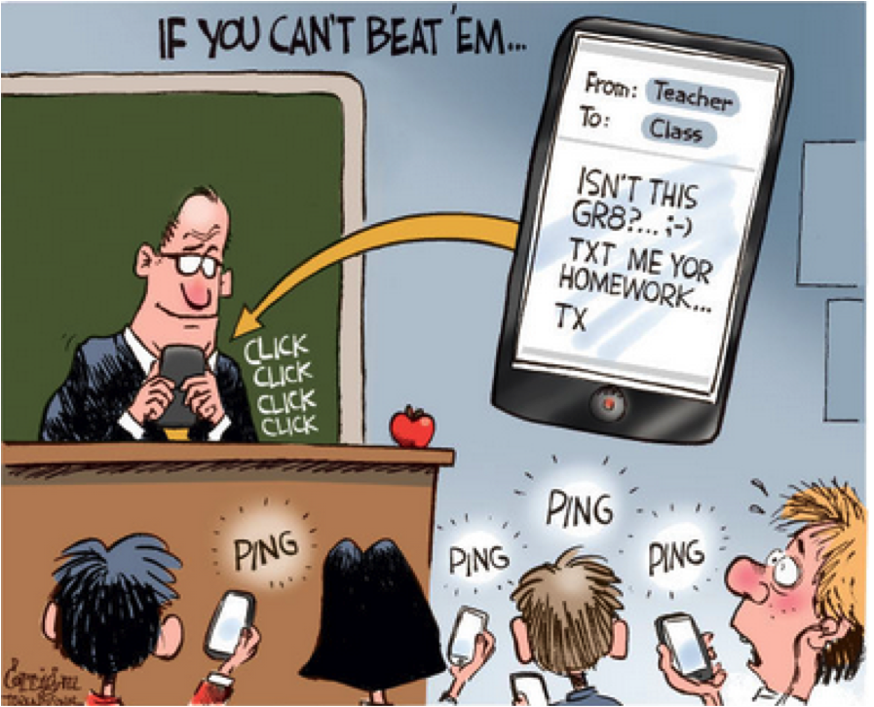
3. Use technology in the classroom by having your students download
Google Bilingual Dictionary from the Google Play store or other useful application that includes pronunciation sounds.

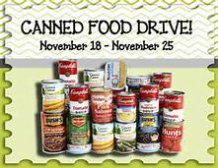
3. Conduct a can food drive to benefit peers in other classrooms.

4. Play the "Ticket to Leave/Exit" game at wrap up time to allow the students to articulate something they learned during that class. Challenge them even more by asking them to not repeat what other classmate has said.

5. Invite former AELG students as Motivational Speakers to share their positive and encouraging experience with Intermediate students. Such as former student Juan Guzman.

6. Invite a Representative from the EOC (Educational Opportunity Center) to speak to Intermediate and Advanced students about Admissions, Financial Aid, Taking the best Accuplacer Exam, etc. Pedro Mejia and Beverly Coleman from the EOC, Takoma Park Campus conducted one at WOMS on February 15^{th.} The students themselves expressed how very knowledgeable and engaging they were.

7. Request a combined presentation from a College and Career Coach. Including any two topics: (1) Foreign credential evaluation, (2) Job search strategies, (3) Resume development, (4) Interviewing skills, (5) Financial aid and Scholarship information and any topic related to (6) Entering the workforce or (7) Continuing their education. We had Jackie Williams and Darrell Burns conduct a presentation at WOMS and they were both knowledgeable, well prepared and enthusiastic.

8. Display all the current flyers of all Vocational Classes, Citizenship classes, GED classes, EOC, How to obtain you Student ID Card, etc. Ask the teachers to bring all their students at staggered times to read the flyers and ask questions about anything that interests them.

9. Organize an "International Night" where the students will research facts about their countries, write important information on a poster board and display it in the hallway. They can work in pairs and should be prepared to answer questions from their peers.

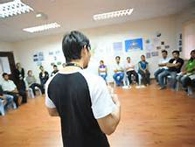

By Amavi Forsythe, ESL Adjunct Professor at WOMS
Wynter Oshigeru, ESL Adjunct Professor at WOMS
Gloria Palencar, Site Mentor at WOMS
Ann Rose, ESL Adjunct Professor at WOMS

